- Look at the picture and answer the questions.
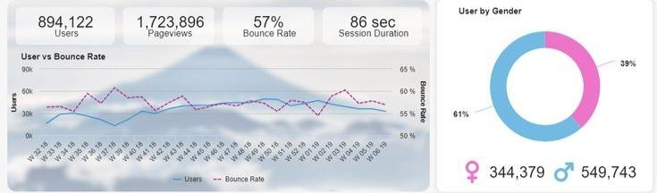
Which box shows:
- how many people visit the website?
- what percentage of people view only one page on the website?
- how much time do users spend on the website?

2. Match the website analytics to the description.
- Traffic | - Information about where the visitors to your profile are from
- meta tag | 2. Invisible information (hidden keywords) on a website
- visitor map | 3. Information about a user and the sites they browse
- user profile | 4. Increasing the number of visitors to your site
- page optimization | 5. The movement and actions of visitors to your site

- e)
3. Choose the correct answer
1) A shopping cart is an important part of
a) a News website
b) a Non-profit website
c) an e-commerce website
2) the “Donate” button is common for
a) a Business website
b) a non-profit website
c) Entertainment websites.
4. Complete these sentences about the purpose of websites with the words in the box.
to read to support to buy/purchase to watch to find out

1. People visit BBC international news.
2. I visit aspca website animals.
3. Customers use Amazon.com to goods.
4. I go to Netflix some interesting movies.
5. People visit the website of this Spa center about their services and prices.

5. Describe your favourite websites using the words below:
informative
fun
professional
Stylish
easy to use/navigate
difficult to use/navigate
clear
well-designed
Grammar note!
Many/ few - countable
many users
few users
many websites

little/much - uncountable

little money, much knowledge, much time, little traffic

a lot of / some - with countable and uncountable
A lot of businesses need E-commerce upgrades
Some money was spent on advertisements.

6. Choose the correct option
1. A lot of/much shops have an online presence. They sell many/much products online.
2. Some/little companies offer customer service and advice on their E-commerce websites.
3. I don’t have many/much time for shopping so I buy everything online.
4. I don’t have much/ few knowledge of computers, but I can still shop online.
5. Companies spend a lot of/ many money on advertisement.
6. This website has little/many traffic so we need to optimize it.
7. This website is well-designed so it has little/many users.

7. Read the 7 Key Features Online Shoppers Demand From an Online Store. Decide which of them are the most important for you.
- A mobile website option.
- Free or competitive shipping options.
- Advanced navigation and search functions.
- Superior photos and image options.
- A detailed product description.
- Customer reviews of the product.
- A fast guest check-out option.
shipping - synonym to delivery.
superior - of a very good quality
review - feedback on something
check out - to complete the buying process by paying for the products on the website.
8. What are the steps in buying products online? Number these sentences in the correct order. (some parts can be different on different websites).
a) The customer opens an account.
b) The customer goes to the check-out.
c) The customer puts the item(s) in a basket or shopping cart.
d) The customer pays for the product(s ) with a credit or debit card.
e) The customer goes to the website. 1
f) The customer searches and/or browses the website.
g) The customer chooses the item(s) to buy.
h) The customer checks the order.

9. Repeat these phrases.
1. open an account
2. go to the checkout
3. put an item in the basket
4. browse the website
5. choose an item
6. check the order
10. Additional task!
Have you ever heard about this term? What relation to website design it might have?
Watch the video. What types of “Dark patterns” exist?
Dark Patterns in UX | Understanding with Unbabel
Have you ever noticed dark patterns on websites you use?
Super Secret task!
Find an example of Dark Patterns in my video for this lesson (one of the websites I show).

